Working Group 4  Contacts between people |  | 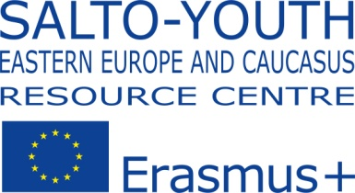

Participant questionnaire

Photo Contest "Youth Creates Contacts between People!"
https://www.facebook.com/groups/525592474155838

1. Personal information
Name and surname of the author (or contact person from organization)
e-mail (obligatory), FB contact, web-site
Country (obligatory),
Postal address
Name of your organization (obligatory)

Telephone with international code (obligatory)
2. Number of photos:
3. Description of photos - for every photo it is necessary to provide the following information:
Photo_number:
- Name of your photo
- Name of file (for example, Ukraine_Ostapenko_ 1.jpg)
- Name of the author and organization
- Name of the project
- Period and location (country, locality) where the project took/taking place and where the photo was made
- List of the partners from EaP and EU countries participating in the project
- Description of the photo and the project (2-4 lines)

The questionnaire and photos should be sent on
eapwg4contest@gmail.com by November 09, 2015

- theme of the letter: «EaP_WG4_Contest_Country _Surname of participant»
- all files should be numbered and named in the following format: questionnaire for participants - Country _Surname of participant (i.e Ukraine_Ostapenko.doc); photo pictures – Country _ Surname of participant_ number of photo (for example, Ukraine_Ostapenko_ 1.jpg, Ukraine_Ostapenko_ 2.jpg etc.).

