Working Group 4  Contacts between people | 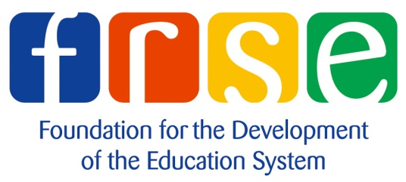 | 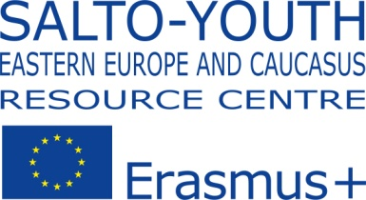

Invitation for participation in the Eastern Partnership Civil Society Forum Working Group-4

Photo Contest "Youth Creates Contacts between People!"

The Working Group-4 of the Eastern Partnership Civil Society Forum (https://www.facebook.com/groups/525592474155838) is glad to announce Photo Contest “Youth Creates Contacts between People!" in the framework of the priorities of the Eastern Partnership Civil Society Forum (EaP CSF).

EaP CSF Working Group “Contacts Between People” consists of civil society organizations from Armenia, Azerbaijan, Belarus, Georgia, Republic of Moldova and Ukraine. The activities of this working group are aimed to implement the reforms in areas that include visa facilitation, education, youth, culture and contacts between seniors.

The main objectives of the photo contest "Youth Creates Contacts Between People!":
- to promote contacts between people through presentation of youth project’s experience of civil society organizations in EaP countries within the Youth in Action Programme (2007-2013), Eastern Partnership Youth Window (2012-2013) and Erasmus+ Programme (2014-2020);
- to raise visibility and awareness of the ERASMUS+ Youth opportunities in the field of youth for the Eastern Partnership countries;
- to promote non-formal learning approach and youth international cooperation with the Eastern Partnership countries.

The partner of the contest is SALTO Eastern Europe and Caucasus Resource Centre (http://www.salto-youth.net/eeca/).

The photos will be published on FB group of Working Group-4 of the Eastern Partnership Civil Society Forum (https://www.facebook.com/groups/525592474155838) and available for public voting. The winners of the contest will be defined by juries taking into consideration the results of e-voting. The winners will be named and the best photos will be presented in photoexhibition at the 7th Annual Assembly of the Eastern Partnership Civil Society Forum in Kiev in November 19-21, 2015.
The winners will be awarded with special prizes provided by SALTO Eastern Europe and Caucasus Resource Centre. One of them is participation in international youth event in 2016.

Terms and conditions of the contest

Eligible participants:
      - People from Armenia, Azerbaijan, Belarus, Georgia, Republic of Moldova and Ukraine who participated or are part of youth project with partners from EaP countries within the Youth in Action Programme (2007-2013), Eastern Partnership Youth Window (2012-2013) or Erasmus+ Programme (2014-2020).

Civil society organizations from Armenia, Azerbaijan, Belarus, Georgia, Republic of Moldova and Ukraine implementing or had implemented/participated project with partners from EaP countries within the Youth in Action Programme (2007-2013), Eastern Partnership Youth Window (2012-2013) or Erasmus+ Programme (2014-2020).

Each participant can provide from 1 to 5 works for the contest.

Technical requirements for photo pictures:
JPG format with resolution 300 dpi for color picture and 600 dpi for black and white picture (file size cannot exceed 2 Mb). The photos should be sent via e-mail together with the questionnaire for participants on eapwg4contest@gmail.com no later than November 9, 2015р. in the following format:
- theme of the letter: «EaP_WG4_Contest_Country _Surname of participant»
- all files should be numbered and named in the following format: questionnaire for participants - Country _Surname of participant (i.e Ukraine_Ostapenko.doc); photo pictures – Country _ Surname of participant_ number of photo (for example, Ukraine_Ostapenko_ 1.jpg, Ukraine_Ostapenko_ 2.jpg etc.).

The deadline is November 09, 2015р.

Detailed information and questionnaire for participants are available via
e-mail: eapwg4contest@gmail.com

Contact persons:
Hovsep Khurshudyan, EaP WG4 Coordinator, "Free Citizen" Civic Initiatives Support Center, Armenia, hovsepkhurshudyan@gmail.com
Oksana Bondar, National WG4 Coordinator, Vinnyitsia Regional Informational Center "Kreativ", Ukraine, oksana.bondar.v@gmail.com

