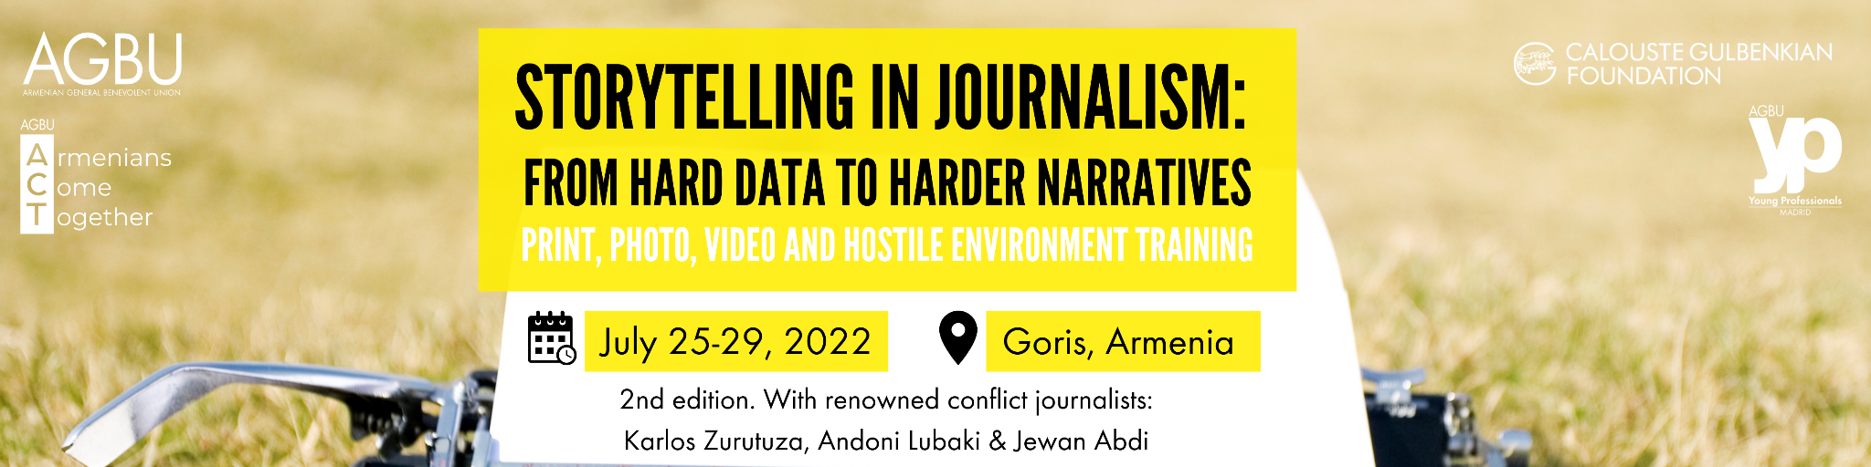

Media Training Program 2022 in Goris, Armenia
Award and Application Information

Objective:
The purpose of this training is to equip potential journalists, who live in or around conflict zones in Armenia and Artsakh, with the proper tools and skill-set in producing effective content so that they can reach an international audience. Other than full time journalists or journalism students, we also look for writers or bloggers who are active on social media and want to switch from activism to journalism. Regardless of their background, all participants must have the drive, passion and commitment to bring local stories to a global audience.

The training will be led by renowned journalists and conflict specialists: Karlos Zurutuza, Andoni Lubaki and Jewan Abdi. It focuses on human rights and conflict issues, develops sensibilization campaigns and conducts media training workshops in conflict and post-conflict regions.

Scholarships that cover the participation fees of the second annual Media Training Program: “Storytelling in Journalism: from hard data to harder narratives,” as well as accommodation expenses and breakfast and lunch for its duration, will be provided to up to 25 people living in Armenia and Artsakh. Transportation for participants from Yerevan to and from Goris will also be arranged.

Award Activity:
Awardees will participate in a media training program in Goris, Armenia from July 25 to 29, 2022, for 5 full days. The training will be in Goris due to its geographic significance to the conflict and its location being between Yerevan, Syunik and Artsakh. Transportation for participants from Yerevan, or Stepanakert, to and from Goris will be arranged.

The training will be conducted in English and the activities are organized in four different blocks (ten hours each):
1. Print/Online journalism
2. Photography/Editing
3. Video/Editing
4. Hostile Environment Training

At the end of the course, the students will be familiar with the basics of print journalism (news, features and interviews) and they will also be capable of bringing together various multimedia elements, from writing for online to recording and editing video. Other key issues that will be covered include: how to approach the international media and pitch their work, as well as Hostile Environment Training. Activities will be led by Karlos Zurutuza, Andoni Lubaki and Jewan Abdi.

Application timeline:
- The application opens on May 9th and closes on June 5th at 23:59pm (local Armenian time).
- Applications will be reviewed between June 6th and June 26th.
- Results will be released and award winners will be notified on July 27th. Award winners will be asked to confirm their acceptance for the award by July 1st.

Applicant eligibility requirements:
- A current resident of, or originally from, Armenia or Artsakh, with plans to continue to reside there through the near future. Ideally, participants should be based in sensitive regions like Artsakh or Syunik so they can report from the ground when needed.
- Be a journalist, journalism student, writer, blogger, or activist with a passion and drive for reporting on current affairs and conflicts in Armenia or Artsakh.
- Have at least a B2 level of English and be confident in English language writing, reading, speaking and comprehension skills.

Application components:
- Online application form with personal information.
- Curriculum Vitae or Resume, including any active social media accounts or articles/pieces published in blogs, vlogs, media, news outlets, etc.
- Short video in English, of about 1:00 to 2:00 minutes, introducing yourself and your personal/professional background, explaining why you want to participate in this media training program, what your goals are for this training and what you would like to achieve after its completion.
- Optional: Certificate of English language level showing B2 level (upper intermediate) or higher.
- Optional: Letter(s) of recommendation (maximum two letters).

Application:
- Complete the application at: https://bit.ly/trainingapp22 by June 5th at 23:59pm (local Armenian time).
- Please note you will need to sign into a Google account to be able to fill out this application. If you do not already have one, you can create one any time for free.

Contact information:
For questions regarding the award or application, please email: madrid@agbuyp.org

